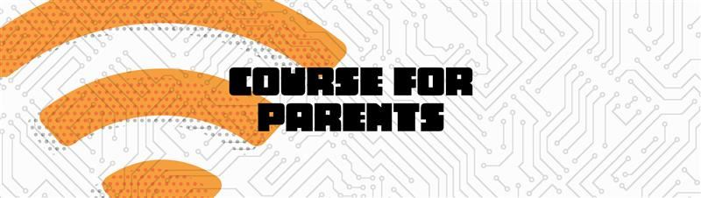

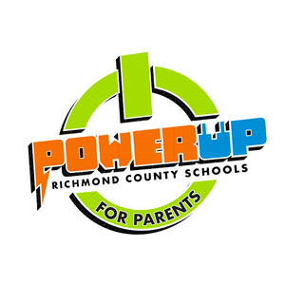

**Parents must complete the PowerUp Parent Course in order for their child to receive a laptop during distribution in October.**

Click the link below for access to the course!

[**Parent PowerUp Course**](https://www.rcboe.org/Page/74682)

**____________________________________________________**

**Parent Name: ________________________________________**

**Student Name: _______________________________________**

**By signing below, I am acknowledging that I have completed the Parent PowerUp Course, and I understand my role to help ensure acceptable and responsible use of the 1:1 device issued to my child.**

**Parent Signature: ____________________________ Date: _______________**